Caps Lock (jQuery) Project pictures

Total images: 03

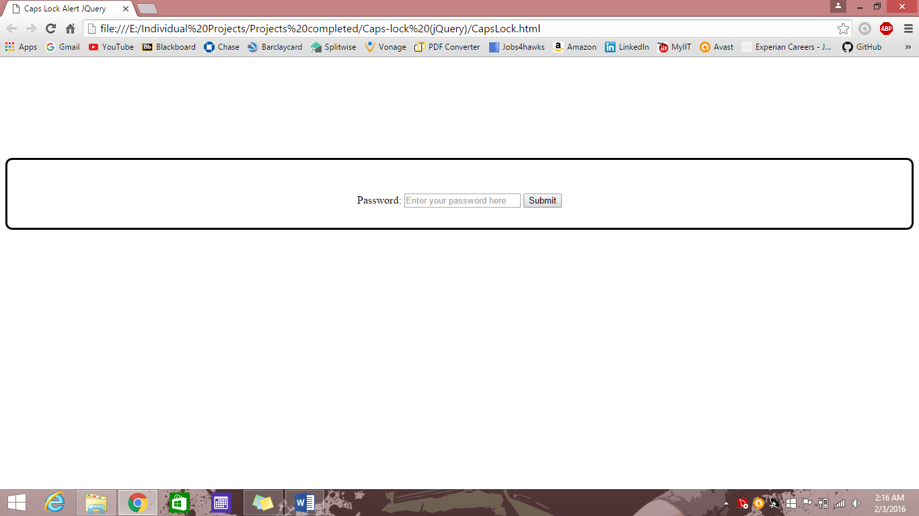

Fig 1: Initial screen

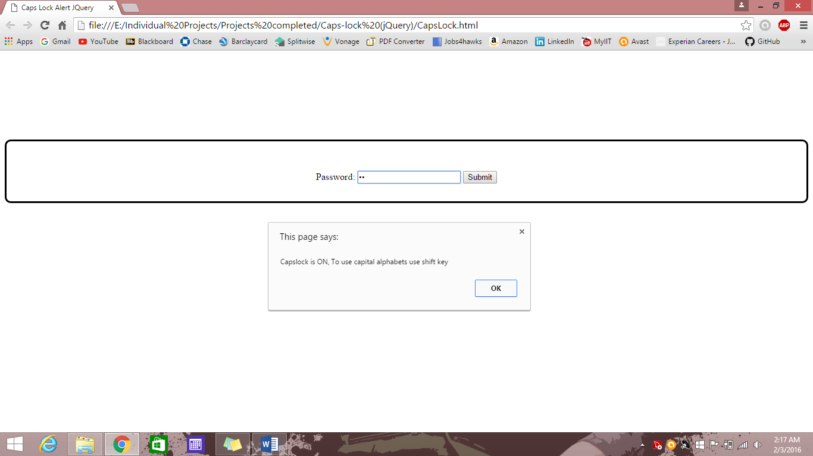

Fig 2: Caps lock alert message popup

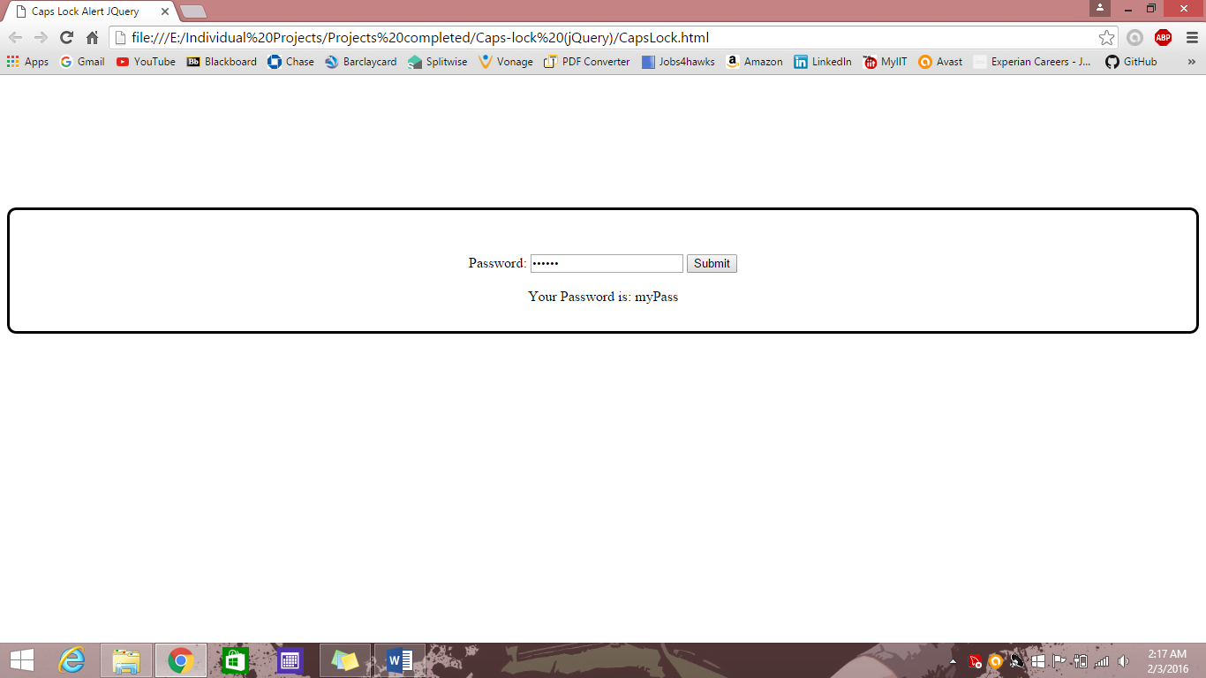

Fig 3: Final input